17.103: a) The possible final states are steam, water and copper at 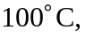 water, ice and copper at 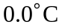 or water and copper at an intermediate temperature. Assume the last possibility; the final temperature would be
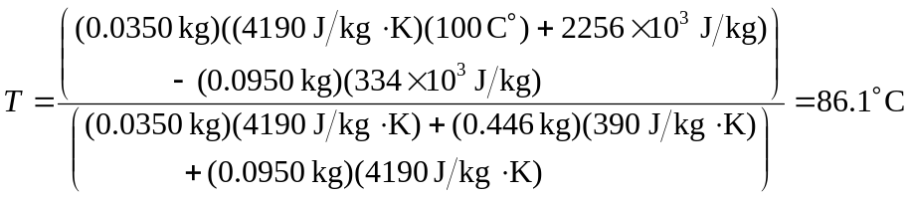
This is indeed a temperature intermediate between the freezing and boiling points, so the reasonable assumption was a valid one. b) There are 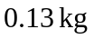of water.

